SUMMER TERM 18th April - 18th July 2024
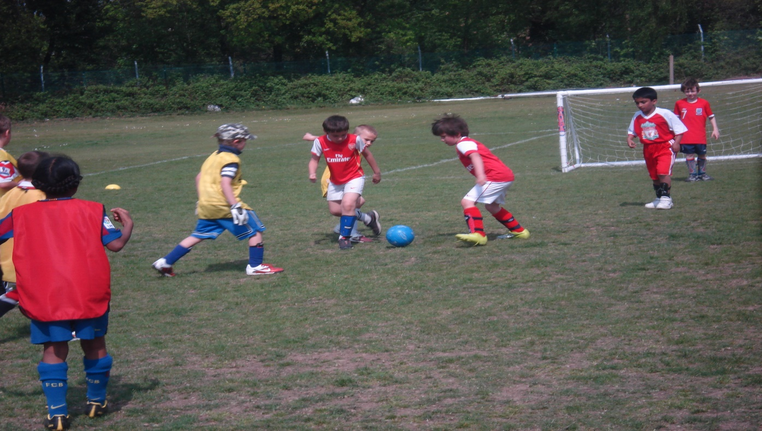
Afterschool Football @ Churchfields Primary
Spring Term 2024 Afterschool Football for children at Churchfields Primary School, Age-appropriate coaching and small sided matches for all abilities, all our coaches are FA qualified, Licensed with DBS, First Aid & Safeguarding certification and public liability and professional indemnity insurance.
book and pay via the pay for sessions tab on our website or give us a call for further information, all places are first come basis. BOOKING IS NOW OPEN
Reception to year 6 every Thursday 3.30pm – 4.30pm
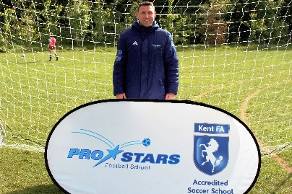
Open to all boys & girls at Churchfields Primary School every Thursday from 3.30pm to 4.30pm from April 18th to July 18th 2024. Payment and registration forms available from our website For further information and registration forms or to book a place for your child visit www.prostarsfootball.co.uk or email prostarsfootball@hotmail.com for more details, places are limited so book early to avoid disappointment.
Mobile 07957 949198 or Office 020 84646453

